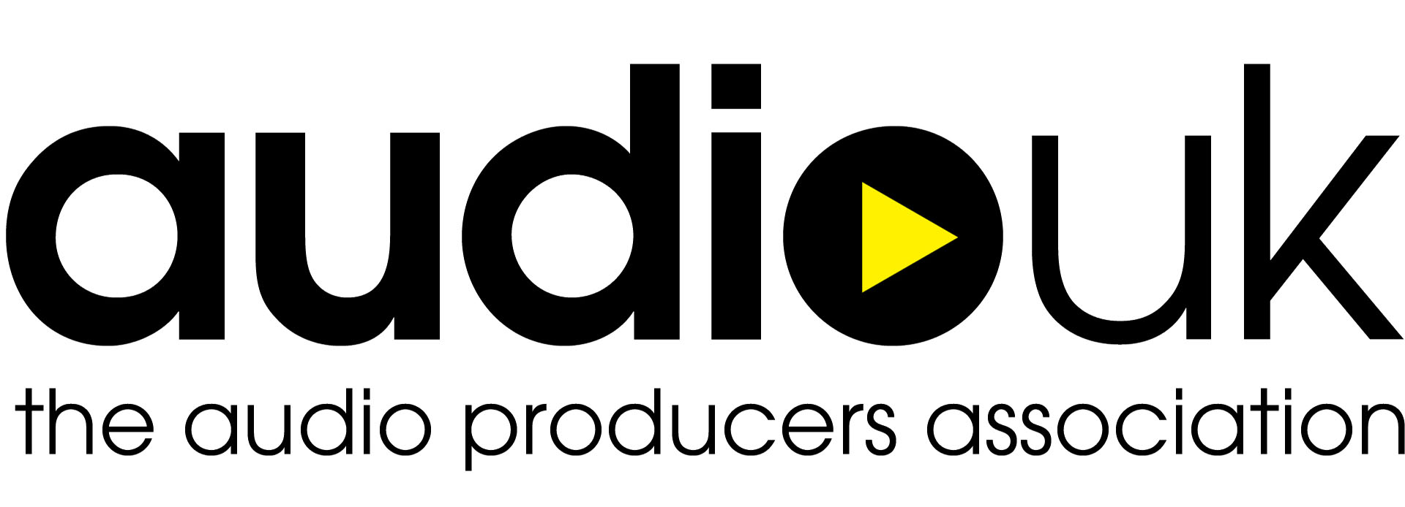

GENERATIVE AI USAGE POLICY

**POLICY**

Artificial Intelligence (AI) is becoming increasingly prevalent in our day to day lives. Whilst the Company welcomes the positive possibilities associated with AI technology, it is recognised that certain usage of AI may be detrimental to organisational integrity. The Company requests that you be aware of the implications of using AI programmes in carrying out your duties as an employee from spreading misinformation to reputational damage.

**“GENERATIVE AI”**

Generative AI, for the purposes of this policy, is any AI software that is capable of generating images, texts, sounds, videos or other data in response to a given prompt. Examples include ChatGPT, Synthesia and Dall-E, although this list is not at all exhaustive.

**DECLARATION**

To ensure transparency in the publication of content, you must declare ALL usage of generative AI. Audio UK reserves the right to refuse publishing where you have failed to comply with the terms of this policy.

**FACT CHECKING & RELIABILITY**

Where you do use Generative AI to assist in the creation of content, you must ensure that it has been thoroughly fact checked to avoid the spread of misinformation. Misinformation can be defined as incorrect or misleading information that is not deliberately deceptive. Failure to fact-check submissions pre-publication may result in disciplinary action.

Disinformation can be defined as false information that is distributed with the intention to deceive. Whilst AI programmes do not exclusively generate misinformation, you should exercise caution when using AI to generate content and/or undertake research.

Where information is verified untrue through fact-check and you intentionally distribute incorrect information, this will be regarded as a distribution of disinformation and will be subject to disciplinary action.

**PLAGIARISM & ORIGINALITY**

Your work must have some value of originality. You should be mindful of plagiarising content from AI-generated texts. All information used in the content creation process should be fact-checked and supporting sources should be referenced appropriately. Where your submissions are found to be of low originality, you may be subject to disciplinary action.

**QUALITY CHECKING**

All content created with aid from AI should be of a standard that is consistent with the expectations of the Company. If a significant and consistent decrease in your performance is detected, you may be subject to disciplinary action in line with the Company’s performance management strategy.

**“DEEPFAKES” AND MANIPULATION OF LIKENESS**

For the sake of this policy, deepfakes are defined as any synthetic media created through the digital manipulation of images, videos and/or audio to replace an individual’s likeness with that of another. This is often done maliciously or as a means of spreading false information.

Under no circumstance should generative AI software be used by employees to replace, mimic, or alter an individual’s likeness without obtaining their express consent prior to generation. All consent provided by individuals should be fully informed, meaning that subjects should be told exactly how their likeness is intended to be used before consent is requested.

Where you have used AI to manipulate the likeness of an individual without gathering informed consent, this may amount to gross misconduct, and you may be subject to disciplinary action. This is especially true where content is of a sexual or derogatory nature, or where there lies malicious intent.

**ETHICAL USAGE**

Generative AI should be used ethically and in a way that avoids causing harm to others. The use of generative AI in the creation of content should not cause distress to others, nor should it be used to defame or deceive. Where you are found to have used generative AI unethically to assist in the creation of content, this may amount to gross misconduct, and you may be subject to disciplinary action.

Should you have any questions regarding this policy or the use of AI in your work, please speak to your Line Manager.

**COPYRIGHTED WORKS**

Where you plan to use copyrighted materials in generation of content (for example, copyrighted music, characters, or logos), you must gain explicit, informed consent from the copyright holder to do so. Consent should be collected in the form of a written statement directly from, and signed by, the copyright holder - this is to be submitted to Audio UK for review beforehand.

**PROTECTION OF PERSONAL AND SENSITIVE DATA**

You should not, under any circumstances, submit the personal data or sensitive data of others (individuals or companies) into generative AI programmes without their explicit, informed consent. Where you submit the personal data or sensitive data of others into generative AI programmes without gaining the appropriate level of consent, this will be treated as a data breach, and you may be subject to disciplinary action.